***Lavender purple teddy bear***

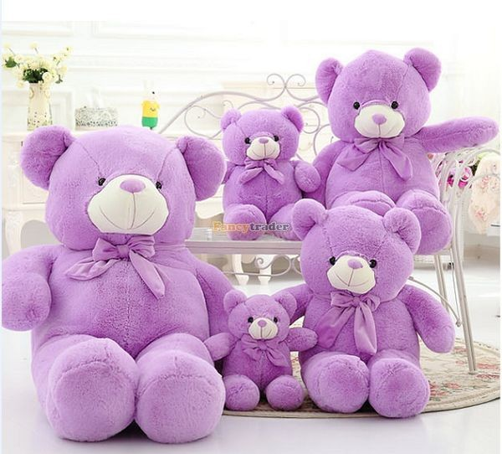

*Lavender purple teddy bear with fluffy and very soft fur. Products are available in different sizes very suitable as a gift for a girlfriend on birthday, Valentine, ... or a gift for children.*